Thursday, Sept 26, 2019

Dear Parents,

Fairfax County Public Schools uses a variety of resources to support student learning. Some of the digital resources your child may use this year require parental consent according to their terms of service and/or privacy policy. FCPS takes your child’s privacy and security very seriously, and follows the guidelines set forth by federal legislation. The tools listed below have been thoroughly reviewed and approved for use in FCPS.

A more detailed explanation of each of the tools can be found on the attached page. After reviewing this document, please sign and return this form to your child’s teacher. You may keep the attachment for future reference.

Student First and Last Name
Grade Level
Parent First and Last Name
Signature of Parent / Guardian

Students are instructed to use their FCPS Google account when logging in and creating an account for each of these resources.

Tool | Purpose | Terms of Service and Privacy Policy
 | Tool for creating digital multimedia lessons | https://www.tes.com/us/terms-and-conditions  https://www.tes.com/us/privacy-policy
 | Coding and computer science lessons and activities | https://code.org/tos  https://code.org/privacy
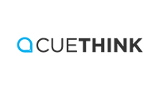 | Tool for supporting problem solving in mathematics | http://www.cuethink.com/terms-of-use/  http://www.cuethink.com/privacy-policy/
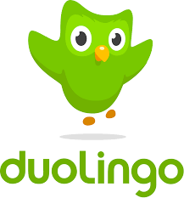 | Tool for learning language through interactive activities | https://www.duolingo.com/terms  https://www.duolingo.com/privacy
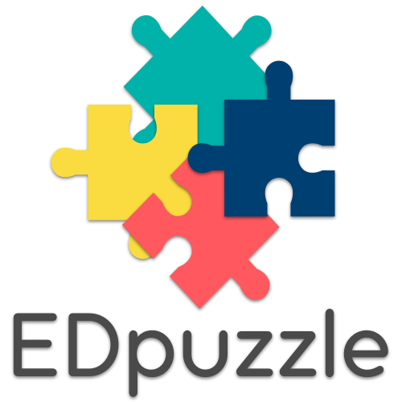 | Teachers and students can annotate videos and create interactive videos for instruction. | https://edpuzzle.com/terms  https://edpuzzle.com/privacy
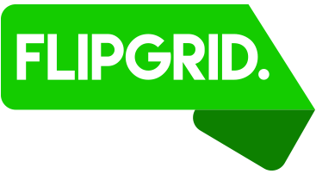 | Video platform for student engagement and formative assessment | https://legal.flipgrid.com/
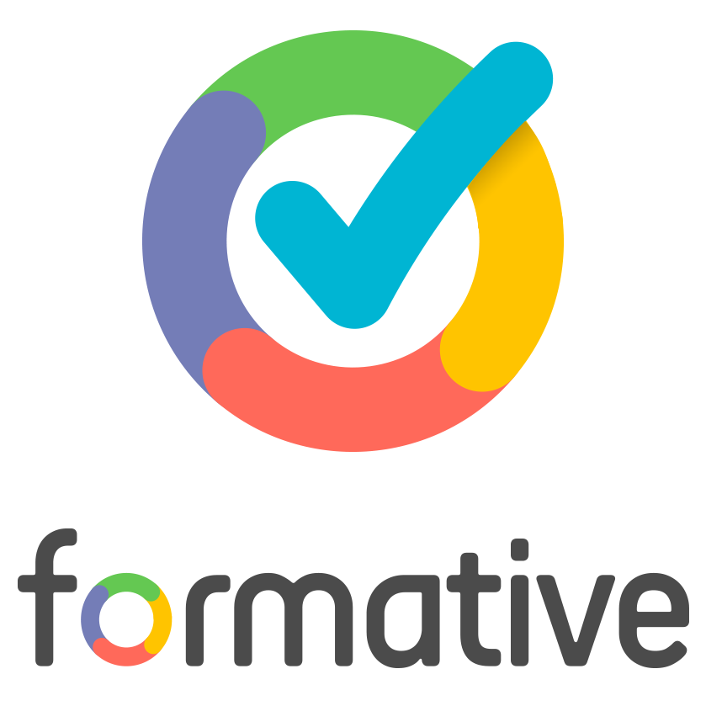 | Activities that check for student understanding | https://goformative.com/tos  https://goformative.com/privacy
 | Resource for learning through videos and practice exercises | https://www.khanacademy.org/about/tos  https://www.khanacademy.org/about/privacy-policy
 | Tool for creating interactive presentations and activities | https://blog.nearpod.com/terms-conditions/  https://nearpod.com/privacy-policy
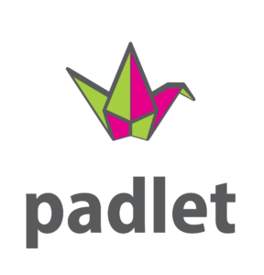 | Virtual bulletin board for collaborating and creating | https://padlet.com/about/terms  https://padlet.com/about/privacy
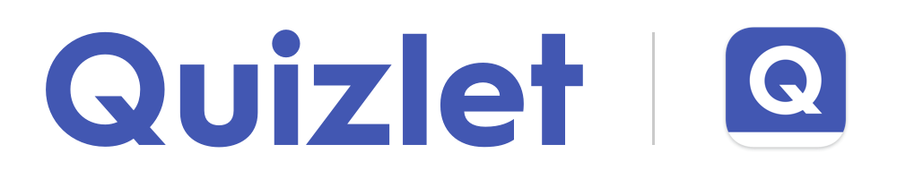 | A study tool for matching terms and definitions | https://quizlet.com/tos  https://quizlet.com/privacy
https://scratch.mit.edu | Program your own interactive stories, games, and animations — and share your creations with others in the online community. | https://scratch.mit.edu/terms_of_use  https://scratch.mit.edu/privacy_policy
 | Project management and organization resource | https://trello.com/legal  https://trello.com/privacy
 | Vocabulary study resource | https://www.vocabulary.com/terms/  https://www.vocabulary.com/privacy/
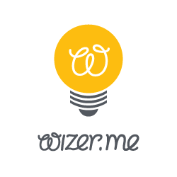 | Allows teachers to combine video, audio, images, and checks for understanding, to create an interactive set of online activities for instruction. | https://app.wizer.me/tos  https://app.wizer.me/privacy

Federal guidelines regarding online safety for children include: Family Educational Rights and Privacy Act (FERPA) Children’s Online Privacy and Protection Act (COPPA) Children’s Internet Protection Act (CIPA)

