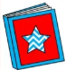
Read Across America Week
March 2-6

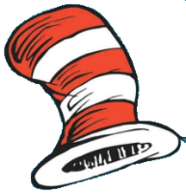
Monday- Cat and the Hat Wear red and white or stripes

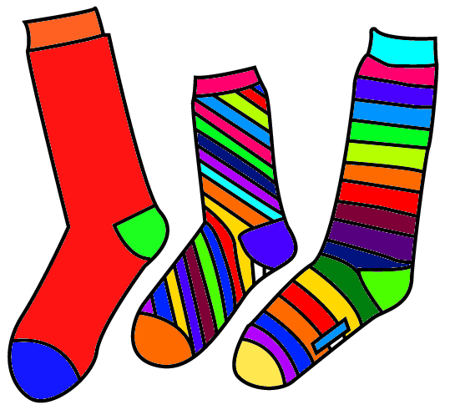
Wednesday- Wacky Wednesday Wear your wackiest socks.

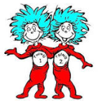
Thursday- Thing 1& Thing 2 Day or Twin Day Plan with a friend and dress like them.
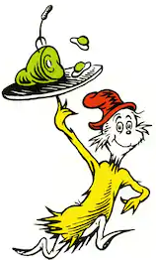
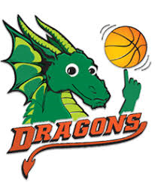
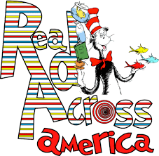
Friday- Green Eggs & Ham- Dogwood Spirit Day Wear Green and come to the 6th grade basketball game.

